ASKINGANDGIVINGDIRECTIONS

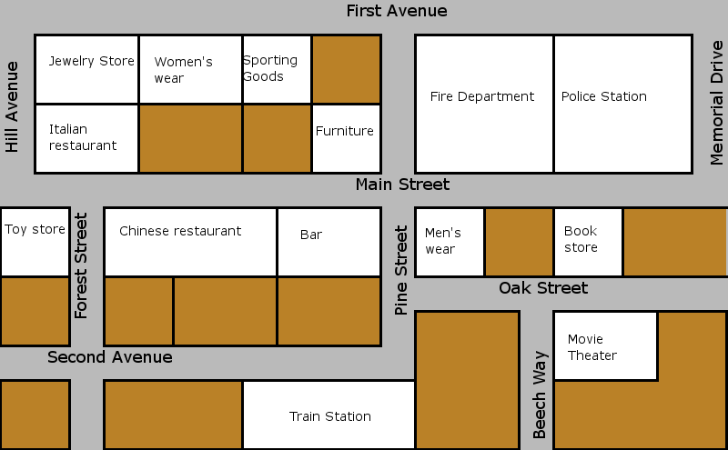

Hospital
Museum
Gas
Station
Parking lot

News
stand

ClothingStore

Bus
stop
Super
market
DryCleaners
Cal’sCafe
Pharmacy
Church
Bank
Park
School
Library

YOU ARE HERE
- Trueor false
- The schoolisnexttothepharmacy T F
- The bar isonthecorner of MainStand Pine St. T F
- The policestationisnexttotheFireDepartment T F
- The toystoreisacrossfromtheChineseRestaurant T F
- The pharmacyisbetweenthetrainsstationandthe hospital T F
- The hospital isacrossfromthe parking lot T F
- The neswsstandisbetweenthelibraryandtheclothingstore T F
- Cal’sCafeisonthecorner of Hill Ave. andMain St. T F
- The movietheaterisnexttothedrycleaners T F
- The gasstationisacrossfromCal’s café.

2) Givedirections

A: Excuse me. Where’sthesupermarket?
You: The supermarket? Go _______ on ____________________turn__________on__________it’s__________fromthemuseum.
A: Thankyou!
You: ____________________.

A: Excuse me. Where’sthebank?
You: Go__________on__________turn__________on__________andturn__________on__________andagainturn__________on__________. The bankis__________theItalianrestaurantandthe bus stop.

